MITRA ALDAGHI

Gastroenterohepatology Research Center, Vasee Teaching Hospital, School of Medicine, Sabzevar University of Medical Sciences

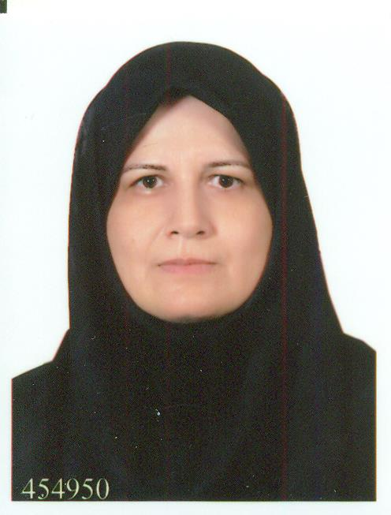

Email :aldaghi@sums.ac.ir

Tel: (office) +98 5144651300-8
Postal Code: 96138 (56764)

PERSONAL INFORMATION

Name: Mitra
Surname: Aldaghi
Date of Birth: 12/03/1963, Sabzewar, Iran
Marriage status: single

EDUCATIONAL BACKGROUND

Pediatric Gastroenterologist graduated from Shiraz University of Medical Sciences, (2014)
Children specialist graduated from Tehran University, (1995)
General practitioner(doctor of medicine) graduated from Mashad University (1988)
High-school Experimental Sciences Diploma, (1981)

THESIS TITLE of Pediatric Gastroenterologist :
“Evaluation of the Correlation between tTG-IgA Titer and Duodenal Biopsy Findings in Children with Suspected Celiac Disease”
(Supervisor: Professor Mohsen Dehghani)

THESIS TITLE Children specialist :
comparison Aminoglycoside effects on Enterobacteriaces ( invivo and invitro) (Supervisor: Professor Ahmad Siadaty)

THESIS TITLE General Practitioner:
Comparison of oral and injection vitamin K on to prevent bleeding disorders neonatal (Supervisor:Professor Gholam Ali Mamori)

Published books

- Practical Neonatal Endocrinology by Amanda Ogilvy-Stuart (Author)translated by DR Mitra Aldaghi (2007)
- Neonatal Abnormalities City of Sabzevar , Author: DR Mitra Aldaghi (2014)

RESEARCH ACTIVITIES
1.. Comparing the effect of different types of surfactant on the treatment of respiratory distress in the premature neonates admitted to NICU of Mobini Hospital of Sabzewar in 2009-2010 , Journal of Sabzevar University of Medical Sciences

2..Gallbladder Hydrops Due to Viral Hepatitis A Infection: A Case Report Jundishapur

J Microbiol. 2015 Jan; 8(1): e15779.
- Evaluation of the Correlation between tTG-IgA Titer and Duodenal Biopsy Findings in children with Suspected Celiac Disease (the acceptance)
- SEVERE HEMATEMESIS IN AN INFANT UNUSUAL,a case report(the acceptance)

CONFERENCE PARTICIPATION
1-Aldaghi M. weekly conference Mobini Hospital 2011
2-Aldaghi M. Conference Gastroenterological diseases in children 2014

3-Aldaghi M. Conference Gastroenterological diseases in children 2015

4-Aldaghi M Care system diseases 2014

WORKSHOPS

- Guideline: Management a child with caustic ingestion 2015 Shiraz University

PROFESSIONAL MEMBERSHIPS:

Member of Children Gastroenterological Association

EXPERIENCE

Computer Skills
- Microsoft office (Word- Power point- Excel- Access), Photoshop
- Reference manager & Endnote

Fieldes of Medicine Interest

- constipation
- celiac disease
- food allergy

HOBBIES
Poem, journey ,book reading

